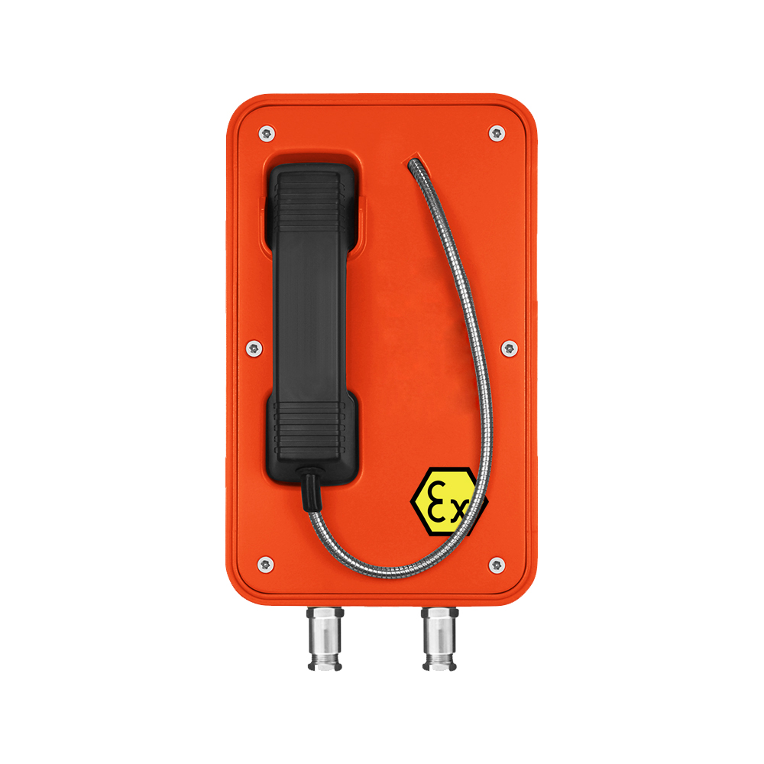 | - Standard Analogue/SIP phone with door  - 80CM vandal resistant handset and cord  - Hotline,without Keypad  - Standard IP 66 weatherproof rating  - Phone line powered (Analogue)  - POE or DC12V powered (SIP )  - RJ45 port for SIP connection  - on wall mounting with mounting bar  - II 2G Ex e ib [ib] mb IIC T4 Gb  - III 2D Ex ib [ib] tb IIIC T135 °  - Zone 1& Zone 2  - ATEX,CE,FCC,Rosh compliant
The Explosion Proof Telephone is designed for voice communication in the hostile environment where reliability,efficiency and safety are of prime importance. The telephone can handle the large temperature differences found outdoors, high humidity, exposure to sea water and dust,Corrosive  atmosphere, Explosive gases & particles, as well as mechanical wear and tear, making it perfect for use as an emergency telephone.The unique robust handset is manufactured from moulded Bulk Molding Compound and designed specifically to withstand arduous use in all environments, armoured cord to provide additional resistance to vandalism or heavy industrial use.  The Explosion-proof and Weatherproof Telephones are designed for use by the chemical plant, Coal Mine,power stations, the armed services and heavy industry which require very reliable and explosion protection telephony under adverse conditions. | SIP-VoIP TECHNICAL SPECIFICATIONS  Power:  12V DC or PoE: IEEE802.3af/at  Port:  WAN: 10/100Base- T RJ-45 for LAN, Auto MDIX  LAN: 10/100Base- T RJ-45 for PC, Auto MDIX  Power Consumption:  Idle:1.5W/ Active:1.8W  Voice Features  - Support SIP 2.0 (RFC3261)  - Codec: G.711A/u, G.7231 high/low, G.729, G.722  - Echo cancellation: Support G.168 and hand-free can support 96ms  - Supports full duplex  - SIP support SIP domain,SIP authentication(none, basic,MD5),DNS name of server  - DTMF:SIP info, DTMF Relay,RFC2833  - Call control feature:Flexible dial map,support hot-line  Network Features  - WAN/LAN: support Bridge mode  - Support static IP address  - Support DHCP get IP on WAN port  - Support VLAN  - Support web config  - Data Protocols: IPv4, TCP, UDP, ICMP, ARP, DNS and DNS SRV for SIP Signaling

Standard Analogue  As a standard analogue telephone, this unit provides basic telephone functions and can be connected to any standard two-wire telephone line, including analogue PABX lines and PSTN.  ANALOGUE  Dialing  MF (tone)  Power supply  Drawn from telephone line  Lightning / Transients  Protection to ITU-T k.21 enhanced levels  Programming  Can be programmed remotely by DTMF tone or building-in keypad  TECHNICAL SPECIFICATIONS  Casing Material  Die cast aluminium,epoxy powder coated. Colors  Available in four colors:  Orange,Yellow,Red and Blue  Handset Material  With Noise canceling microphone,for effective communication from noisy areas(Armored SS cord stands up to rough treatment,optional for black curly cord )  Hook switch  Electronic / magnetic with no visible moving parts  Keypad  Hotline, without Keypad  Temperature: T4  Weather Resistance  IP66(standard)~ IP67(highest rating)  Ringing Tone  Shrill warble tone 80 dBA @ 1 metre typical (Analog)  Shrill warble tone 90 dBA @ 1 metre typical (SIP)  M.T.B.F.  Calculated to have an M.T.B.F. in excess of 50,000 hours using | DIMENSIONS:  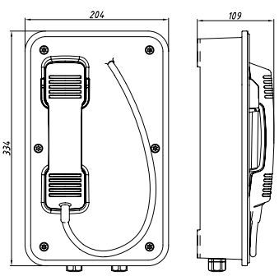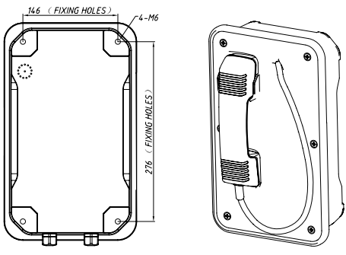  (Measured in mm)  APPROVALS  This mark indicates compliance with the:  Radio & Telecommunications Terminal Equipment Directive  2004/108/EC    This mark indicates compliance with the:  FCC Part 15 Subpart B Class B    This mark indicates compliance with the:  II 2G Ex e ib mb IIC T4 Gb  II 2D Ex ib [ib] tb IIIC T135 °Db  PACKAGE  unit size: 204 *334 *109 (mm)  Carton size:200*300*440 ( mm )  Packaging materials: pearl cotton, carton  Gross weight: 9KG  Net weight: 8KG

